JAVA ASSESSMENT TOOL
CO1-AT3
QUESTION – 1:
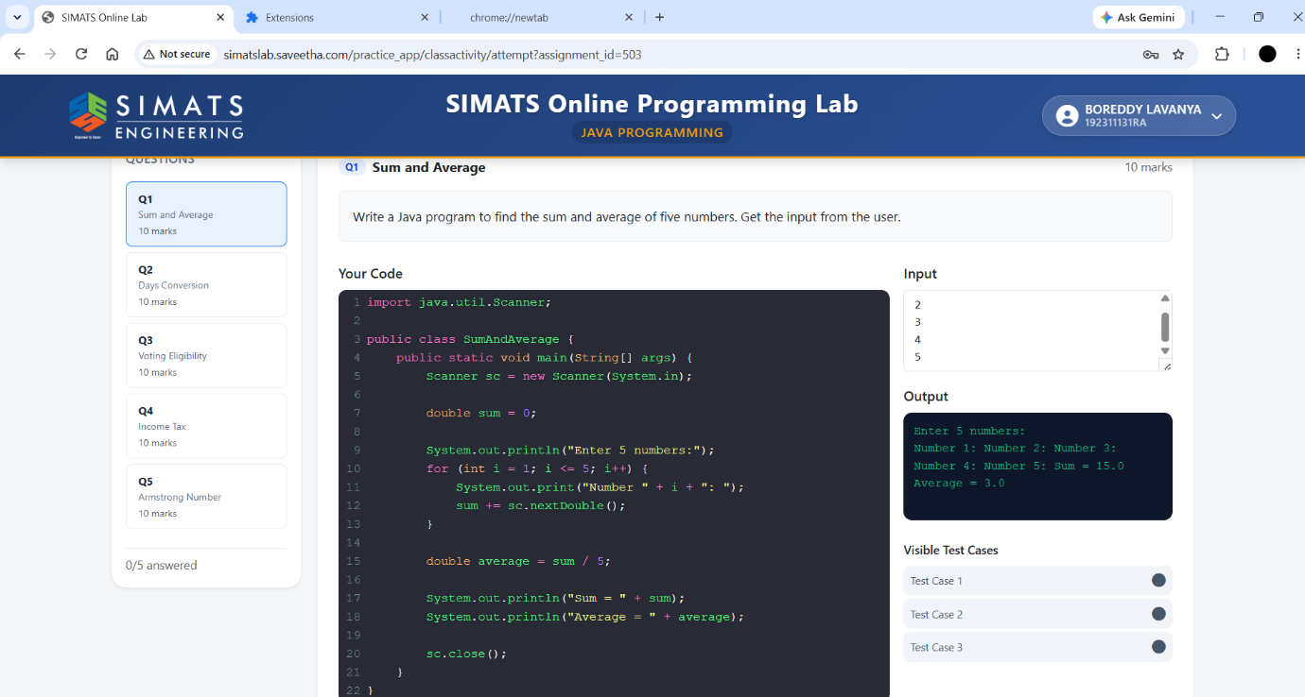
QUESTION – 2:
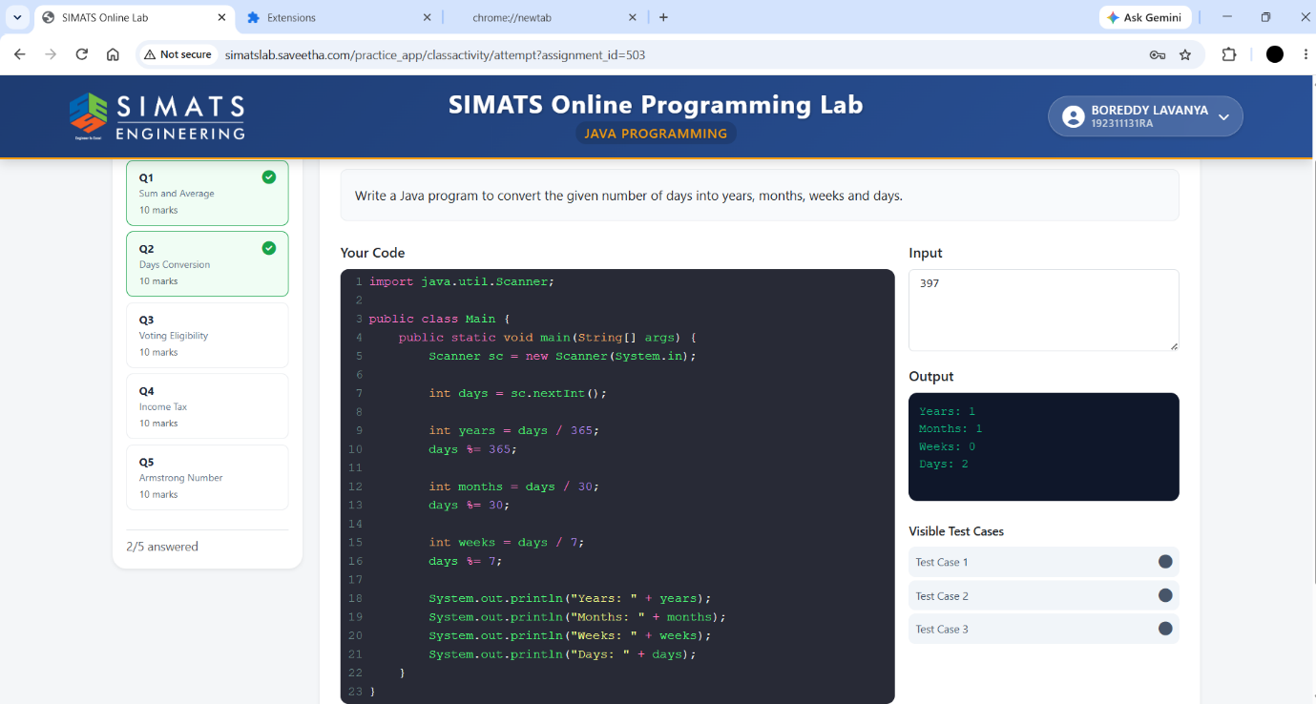
QUESTION – 3:
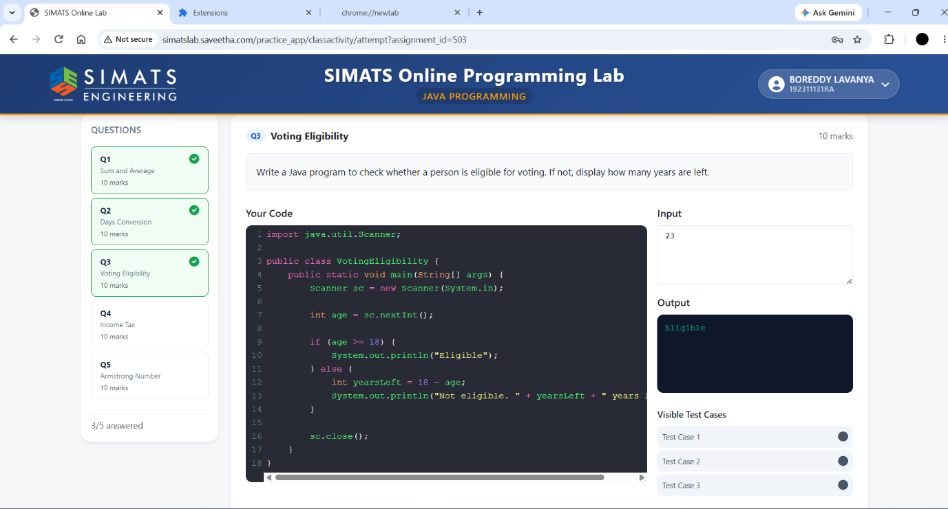
QUESTION – 4:
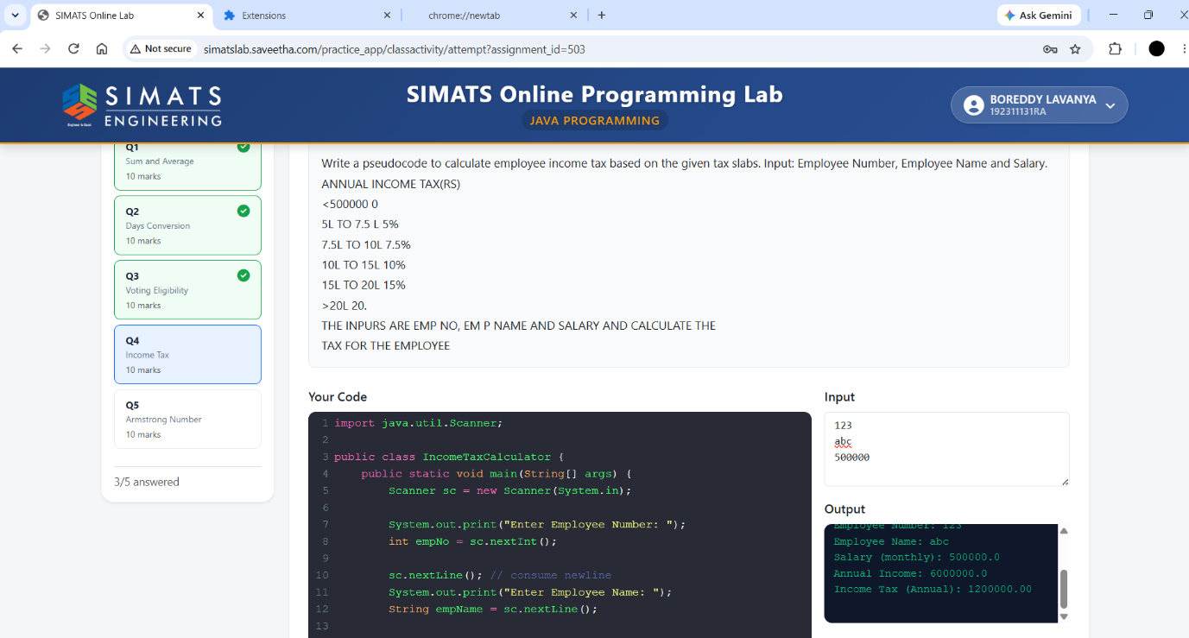
QUESTION – 5:
